EXP NO:2 Implementing TDMA Slot Allocation in GSM.
Objective 1:
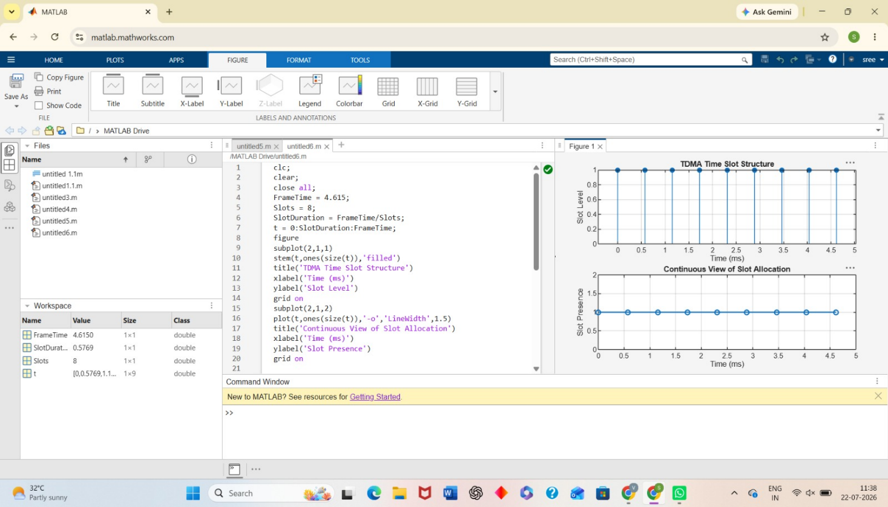
Objective 2:
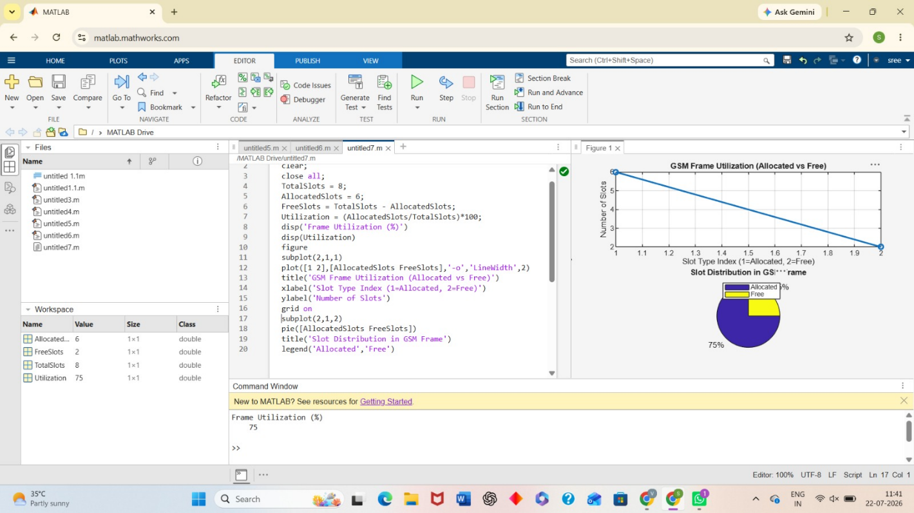

Objective 3:
